# MP3 music player

MP3 music player mainly consists of buttons, speaker, screen and structures. The screen displays the song name, the buttons select the song and switch the song, and the speaker plays the song.

## In this lesson, we will make a simple MP3 music player.

## Install the music player

|  |  |
| --- | --- |
| Remove the red part of the picture below from the electronic photo album of the last lesson  拆下电子相册红色部分 | The remaining structure is shown in the following figure  拆完后 |
| 音乐盒_空白视图 1 | 音乐盒_空白视图 1_1 |
| 音乐盒_空白视图 1_2 | 音乐盒_空白视图 1_3 |
| 音乐盒_空白视图 1_4 | 音乐盒_空白视图 1_5 |
| 音乐盒_空白视图 1_6 | 音乐盒_空白视图 1_7 |
| 音乐盒_空白视图 1_8 | 音乐盒_空白视图 1_9 |
| 音乐盒_空白视图 1_10 | 音乐盒_空白视图 1_11 |
| 音乐盒_空白视图 1_12 | 音乐盒_空白视图 1_13 |
| 音乐盒_空白视图 1_14 | 音乐盒_空白视图 1_15 |
| 音乐盒_空白视图 1_16 | 音乐盒_空白视图 1_17 |
| 音乐盒_空白视图 1_18 | 音乐盒_空白视图 1_19 |
| 音乐盒_空白视图 1_20 | 音乐盒_空白视图 1_21 |
| 音乐盒_空白视图 1_22 | 音乐盒_空白视图 1_23 |
| 音乐盒_空白视图 1_24 | 音乐盒_空白视图 1_25 |
| 音乐盒_空白视图 1_26 | 音乐盒_空白视图 1_27 |
| 音乐盒_空白视图 1_28 | 音乐盒_空白视图 1_29 |
| Wiring diagram | |

## Button to select a song

We firstly display the names of several songs on the screen, and then click to select a song, which is our common menu selection function.

1. **Program idea**

OLED screen shows the song list. One button controls the downward selection of songs, and the other button controls the upward selection of songs.

1. **Example program**

|  |
| --- |
|  |

1. **Experiment phenomenon**

At the beginning, the music menu will be displayed. Click the button on the right to select downward, and click the button on the left to select upward.

|  |  |
| --- | --- |
|  |  |

### Select and enter

In the previous section, we realized the preliminary function of menu selection. In this lesson, we further realized the menu function, select and enter the function.

1. **Program idea**

In the previous section, we used two buttons to select songs up and down. This time, we only used one button to control the selection down. If it goes beyond that, it will return to the first song name.

Click the button on the right to select a song, long press the button on the right to enter the selected song interface, and click the button on the left to exit the entered song interface.

1. **Example program**

|  |
| --- |
|  |

1. **Experiment operation and phenomenon**

Click the button on the right to select a song, long press the button on the right to enter the selected song interface, and click the button on the left to exit the selected song interface.

|  |  |
| --- | --- |
|  |  |

### Enter the selected song interface and play the song

1. **Staff**

To play a song, you need to write the tone of the song. There are three songs we have prepared, “Little star”, “Two tigers”, “Worms Fly”.

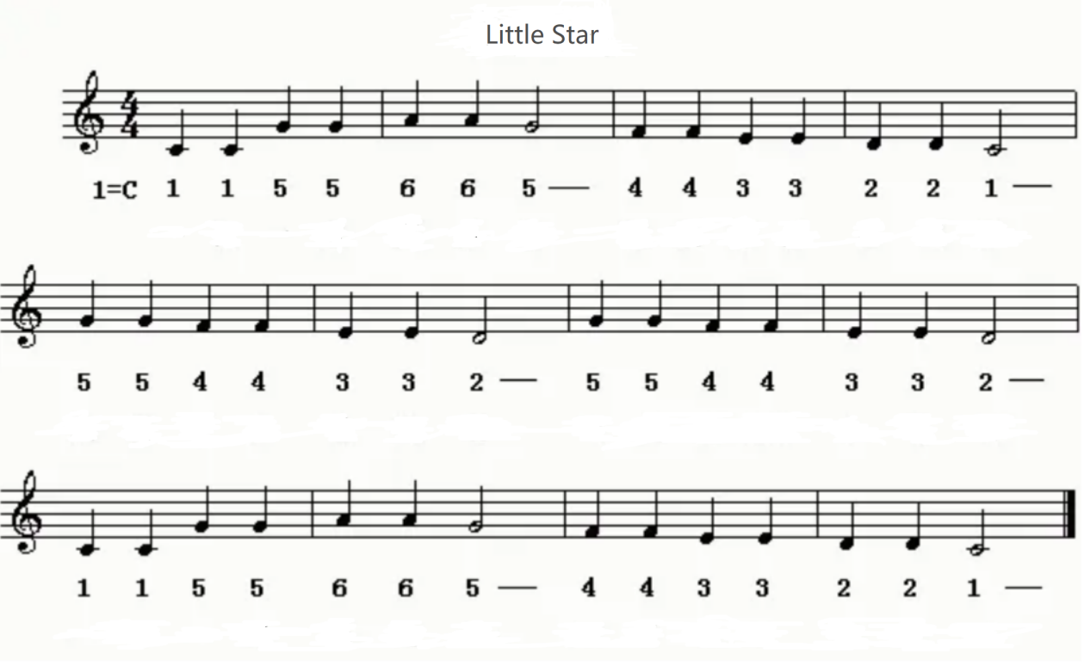

You can see that the score starts with 4 4, the quarter note is one beat, and each bar has four beats, 1=C, that is, C key.

The time of a bar is 1 second. A solid note is a quarter note, which is 1/4 beat, and the pause time is 1/4 second. A hollow note is a half note, which is 1/2 beat, and the pause time is 1/2 second.

According to the staff of “Little star”, let's write its corresponding notes first. Both upper and lower case are the same. We write uppercase characters, starting with the mediant C4.

Because most of them are 1/4 beats, the following ones with /2 are 1/2 beats, and the others are 1/4 beats.

C4、C4、G4、G4、A4、A4、G4/2、F4、F4、E4、E4、D4、D4、C4/2、

G4、G4、F4、F4、E4、E4、D4/2、G4、G4、F4、F4、E4、E4、D4/2、

C4、C4、G4、G4、A4、A4、G4/2、F4、F4、E4、E4、D4、D4、C4/2

Now we have written all the notes of “Little star”.

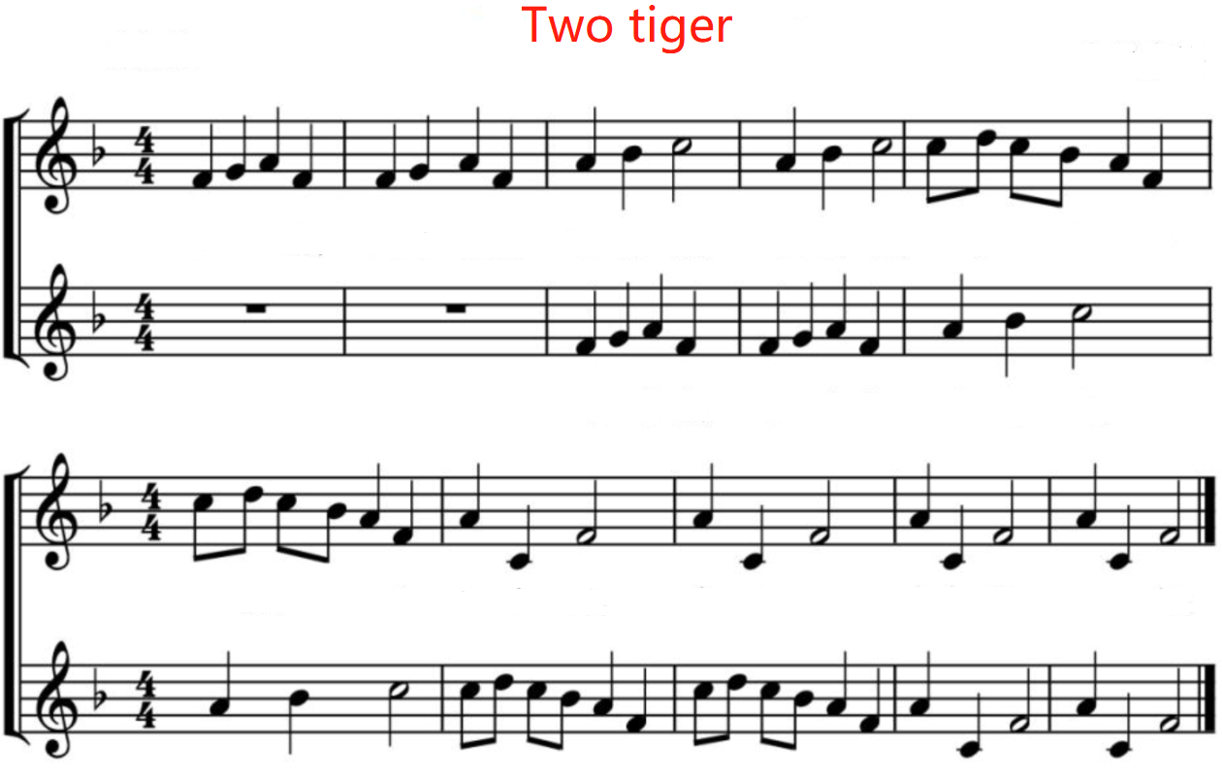

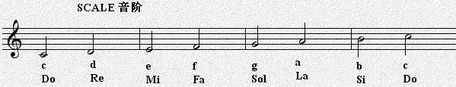

The tone of “Two tigers”:

F4 , G4 , A4 , F4 , F4 , G4 , A4 , F4

A4 , B4 , C5/2 , A4 , B4 , C5/2 , C5 , D5 ,C5 , B4 , A4, F4,

C5 , D5 ,C5 , B4 , A4, F4, A4 , C4 , F4/2 , A4 , C4 , F4/2

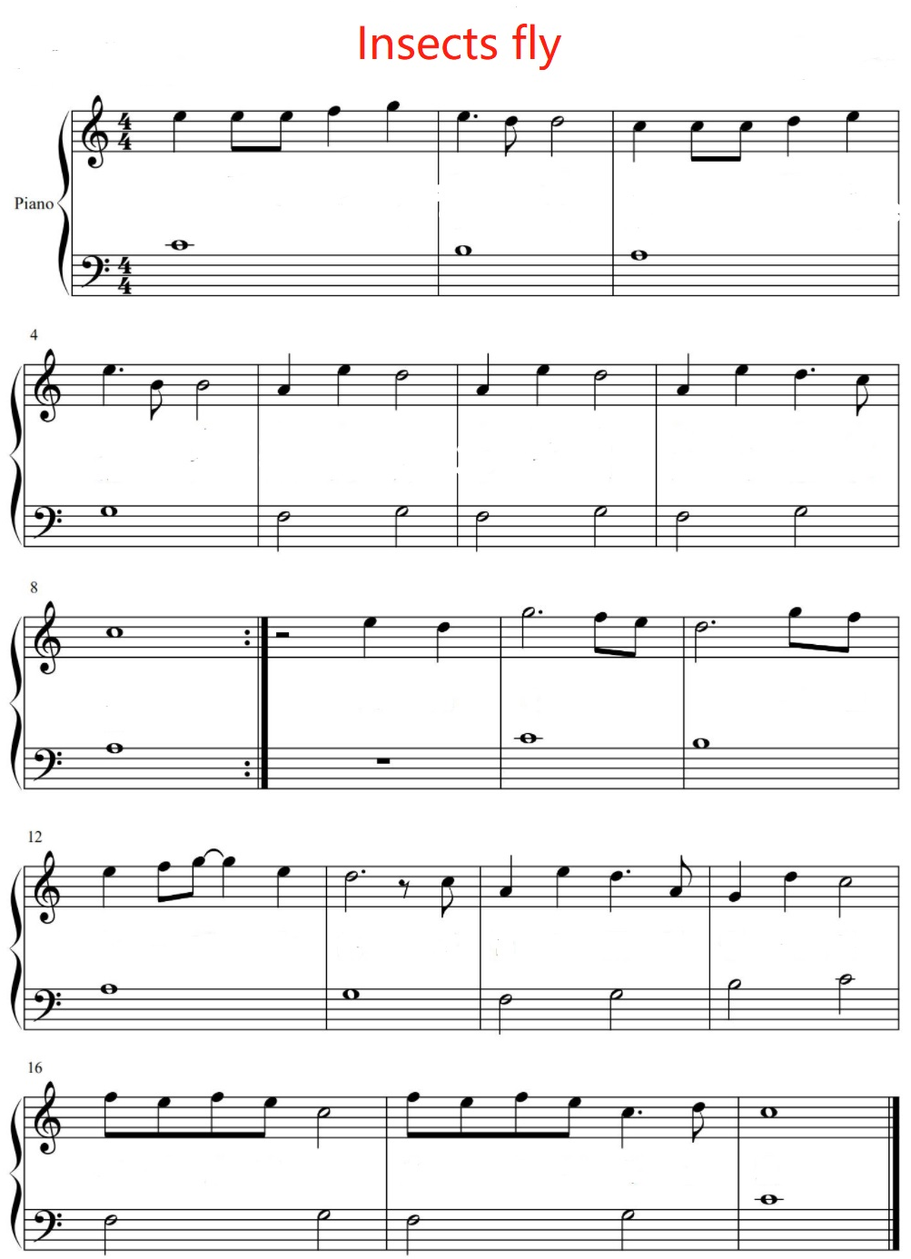



New knowledge of note:

This is a continuous tone, that is, the interval between two tones is very short. We set it to 0.01 second.

This is an eighth note, which is 1/8 second.

This is a whole note, which looks like a circle and lasts for 1 second.

Write the corresponding note according to the staff, the default is 1/4 note, and add - to connect.

E5、E5-E5、F5、G5、E5、D5/8、D5/2、C5、C5-C5、D5、E5、

E5、B4/8、B4/2、A4、E5、D5/2、A4、E5、D5/2、A4、E5、D5、C5/8、

C5/1、E5、D5、G5/2、F5-E5、D5/2、G5-F5、

E5、F5-G5、E5、D5/2、C5/8、A4、E5、D5、A4/8、G4、D5、C5/2、

F5-E5-F5-E5、C5/2、F5-E5-F5-E5、C5、D5/8、C5/1

Final tone:

《Little star》

C4、C4、G4、G4、A4、A4、G4/2、F4、F4、E4、E4、D4、D4、C4/2、

G4、G4、F4、F4、E4、E4、D4/2、G4、G4、F4、F4、E4、E4、D4/2、

C4、C4、G4、G4、A4、A4、G4/2、F4、F4、E4、E4、D4、D4、C4/2

《Two tigers》

F4 , G4 , A4 , F4 , F4 , G4 , A4 , F4

A4 , B4 , C5/2 , A4 , B4 , C5/2 , C5 , D5 ,C5 , B4 , A4, F4,

C5 , D5 ,C5 , B4 , A4, F4, A4 , C4 , F4/2 , A4 , C4 , F4/2

《Worms fly》

E5、E5-E5、F5、G5、E5、D5/8、D5/2、C5、C5-C5、D5、E5、

E5、B4/8、B4/2、A4、E5、D5/2、A4、E5、D5/2、A4、E5、D5、C5/8、

C5/1、E5、D5、G5/2、F5-E5、D5/2、G5-F5、

E5、F5-G5、E5、D5/2、C5/8、A4、E5、D5、A4/8、G4、D5、C5/2、

F5-E5-F5-E5、C5/2、F5-E5-F5-E5、C5、D5/8、C5/1

1. Program block

Add “Insert source program” block

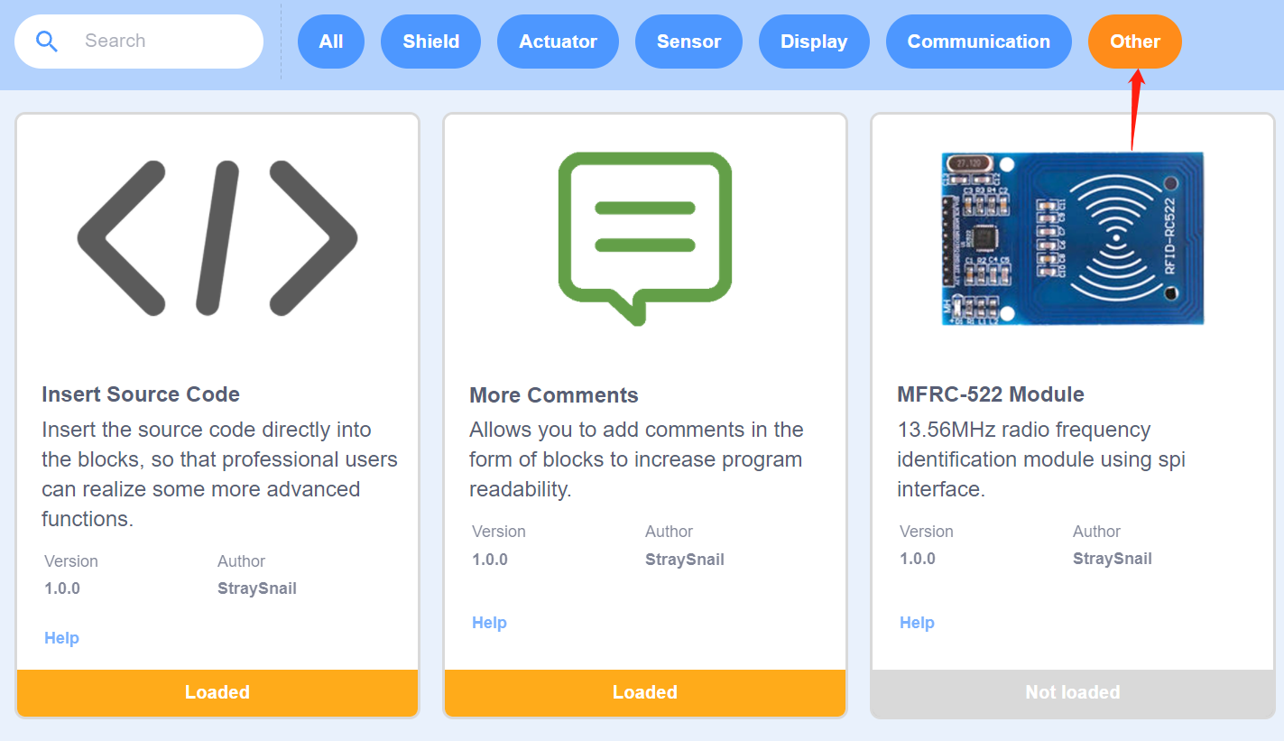

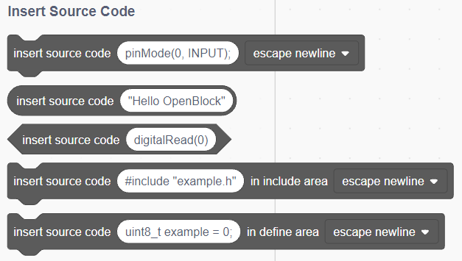

What really works in the program is the code in the source code area on the right of SnailBlock, and the code we upload is also the source code.

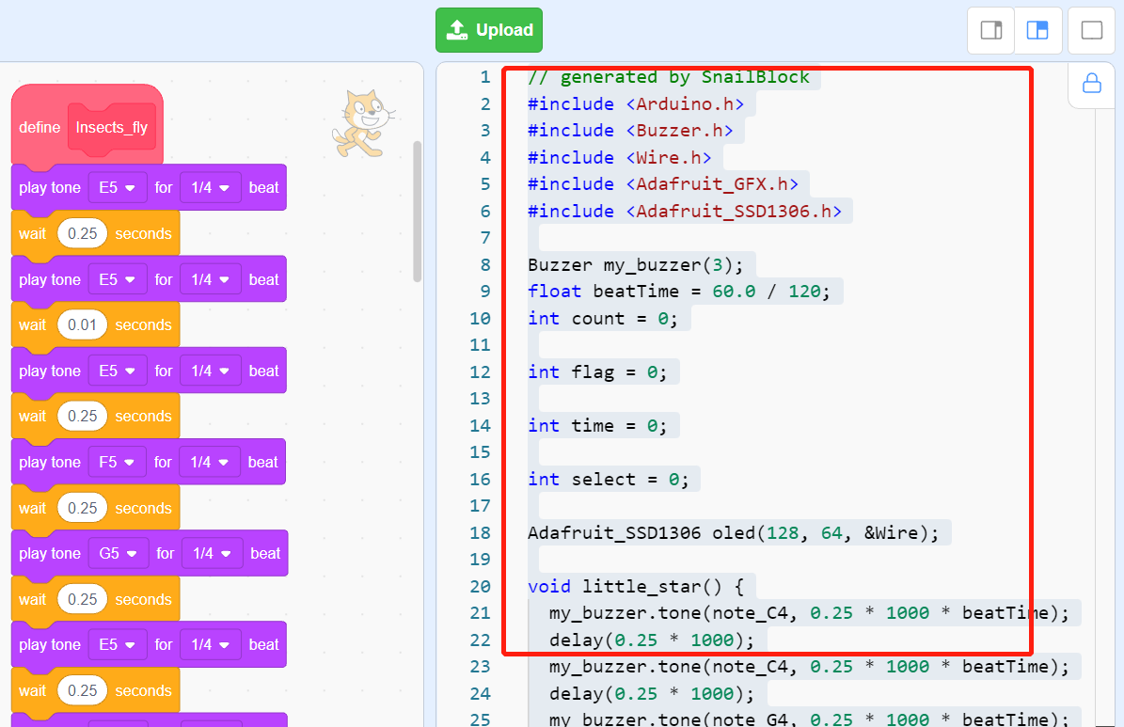

In order to realize the code that is not available in the graphic program block, we have added a program block that can customize the source code.

The “return;” is the source code used in this lesson, which means that the program will return when it runs here and will not run again.

1. Example program

The program is too long. Please open the sample program provided by us to view it. There are comments in it.

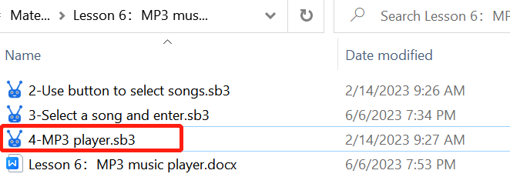

1. **Experiment operation and phenomenon**

Click the button on the right to select a song. Long press the button on the right to play the selected song. Press and hold the left button to exit the song being played.

|  |  |
| --- | --- |
|  |  |